Some of us got names our parents just liked. Some of us are named after parents, grandparents, or family friends. And some of us are named after vampires, Disney princesses, witches, wizards, Kardashians, or the mermaid from *Splash.*

The US SSA has a database documenting popularity for every name given to more than five babies of a given gender in a given year from 1880 through 2017, letting me take a look at trends in the names of fictional and nonfictional pop-culture icons and their relationship to a name’s popularity.

Why look at these trends? In part, just because it’s cool, but also:

* Just as arts and media shape our overall language and lexicon, they create names that didn’t exist or pull them out of obscurity
* Visualizing these trends creates a tangible display of the relationship between pop culture and society overall
* They sometimes solidify something as a “girl thing” or a “boy thing,” and sometimes they make something that was only for one gender ok for both, exposing the relationship between gender and media
* They show the ripple effect of these works. Some of these trends came and went, but others lasted decades because of secondary impact.

## Madison Ave

From 1880 to 1983, Madison was a used consistently year to year but infrequently overall for boys, with an average of about 34 uses per year. From 1880 to 1983, the name Madison was used a **total** of 30 times for girls.

In 1984, the main character from *Splash* christened herself “Madison” based on the famous east side Avenue, and by the end of the year, more girls were given the name Madison (42) than in the last 100 years combined.

By the end of the decade, 3, 789 girls had been named Madison. The popularity peaked in 2001, when 22,164 girls were named Madison in a single year.

## Can you wiggle your nose?

The TV show *Bewitched* had a similarly strong impact on girls’ names; if you know a Samantha, she was probably named after a witch (whether she knows it or not).

From 1880 to 1962, an average of 25 baby girls per year were named Samantha. In 1963, 72 girls were given the name. In 1964 (When Bewitched first aired), the number of girls given the name rose to 418; that number quadrupled in 1965.

The name’s popularity lasted longer and extended further than Madison. Samantha peaked in 1990, 26 years after its initial rise to popularity, at 25,866 girls born in that year.

Some additional highlights:

* The name Darren has a visibly large jump in its popularity as a boys’ name.
* There is a small but consistent trend of naming boys Samantha that starts with the show as well
* You can’t see it in the graph, but the name Darren received a slight boost in popularity as a girl’s name as well—in 1965 it was almost as popular as a girls’ name (25) as Samantha’s mother’s name Endora (28).
* The name Tabitha became 10x more popular in one year when Samantha and Darren had baby Tabitha, and the name’s popularity continued to trend upward.

## Sparkly Vampires

The most notable trend is that book releases had far less, if any impact on the usage of names than movie releases. It turns out, not everyone grew up with a “you can’t watch the movie until you read the book” rule.

This, by and large, hurts my (possibly snobby) nerdy heart. If you find yourself feeling the same way, it sorta gets worse and sorta gets better?

## Witchcraft and Wizardry

**New Names**

The names Draco, Hermione, Sirius, Bellatrix, and Severus were all “created,” for lack of a better word, by the Harry Potter series.

Draco got enough traction to give the books at least some of the credit, but since we don’t have any historical data to compare it to and it’s such a slim window of time, it’s hard to make any kind of claim.

Otherwise, Sirius has a *tiny* bit of use after the book release with a significant uptick after the movie release, and the rest of the names don’t appear until after the character is featured in the movies, or, in the case of Severus Snape, after his big character reveal in appears in the movies.

Admittedly, the trend for Bellatrix makes total sense for me, movie-wise. Helena Bonham Carter is flawless, and I give her a lot of credit for that character/name becoming memorable.

**Other Names**

I didn’t find any really decisive trends for any names that already existed before this series, except one, and true to form, she broke all the rules.

I’ve shown and will show a lot of instances where pop culture intervention, rather than creating a trend, intensifies an existing one. Even looking closely at the Twilight data shows some very slight trends after the book release (Jasper, Esme) that intensify after the movie release.

In the case of the name “Luna,” the release of the book seems to start a trend that holds steady for several years after the movie’s release, indicating to me that regardless of what is responsible for the long-term trend in the name’s popularity, the book series, not the movies, can claim responsibility for kickstarting it.

## I mean, this one is probably responsible for a fair amount of babies

Yes, *this* is the series where I found a decisive impact from the book, not the movie, on the popularity of the main character’s name. I told you: it sort of got better but also sort of worse.

## The one where they named their kids

* Personally, my favorite part of this data is that the name Chandler had been trending upward for both genders from the mid-80s, and 1993 was the first time it was more popular for girls than boys. It feels very on brand for Ms. Shandellar Bong.

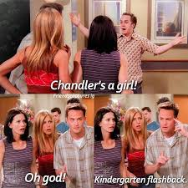

* + From 1994 to 1995, not only did use of the name Chandler for boys make a huge leap, but the trend reversed for girls, solidifying it as more of a “boy’s name.”
* By the mid-90s, the name Phoebe was already trending upward, but it does jump a bit from 1994 to 1995, and the trend gets steeper from there. It’s a little harder to say how much of this is cause and effect.
* The downward trend on the name Monica *may* have been subtly reversing after *Friends* began airing, but when the Lewinsky-Clinton Scandal began making headlines, the name’s usage went off a cliff.

## Keeping Up

**First Gen**

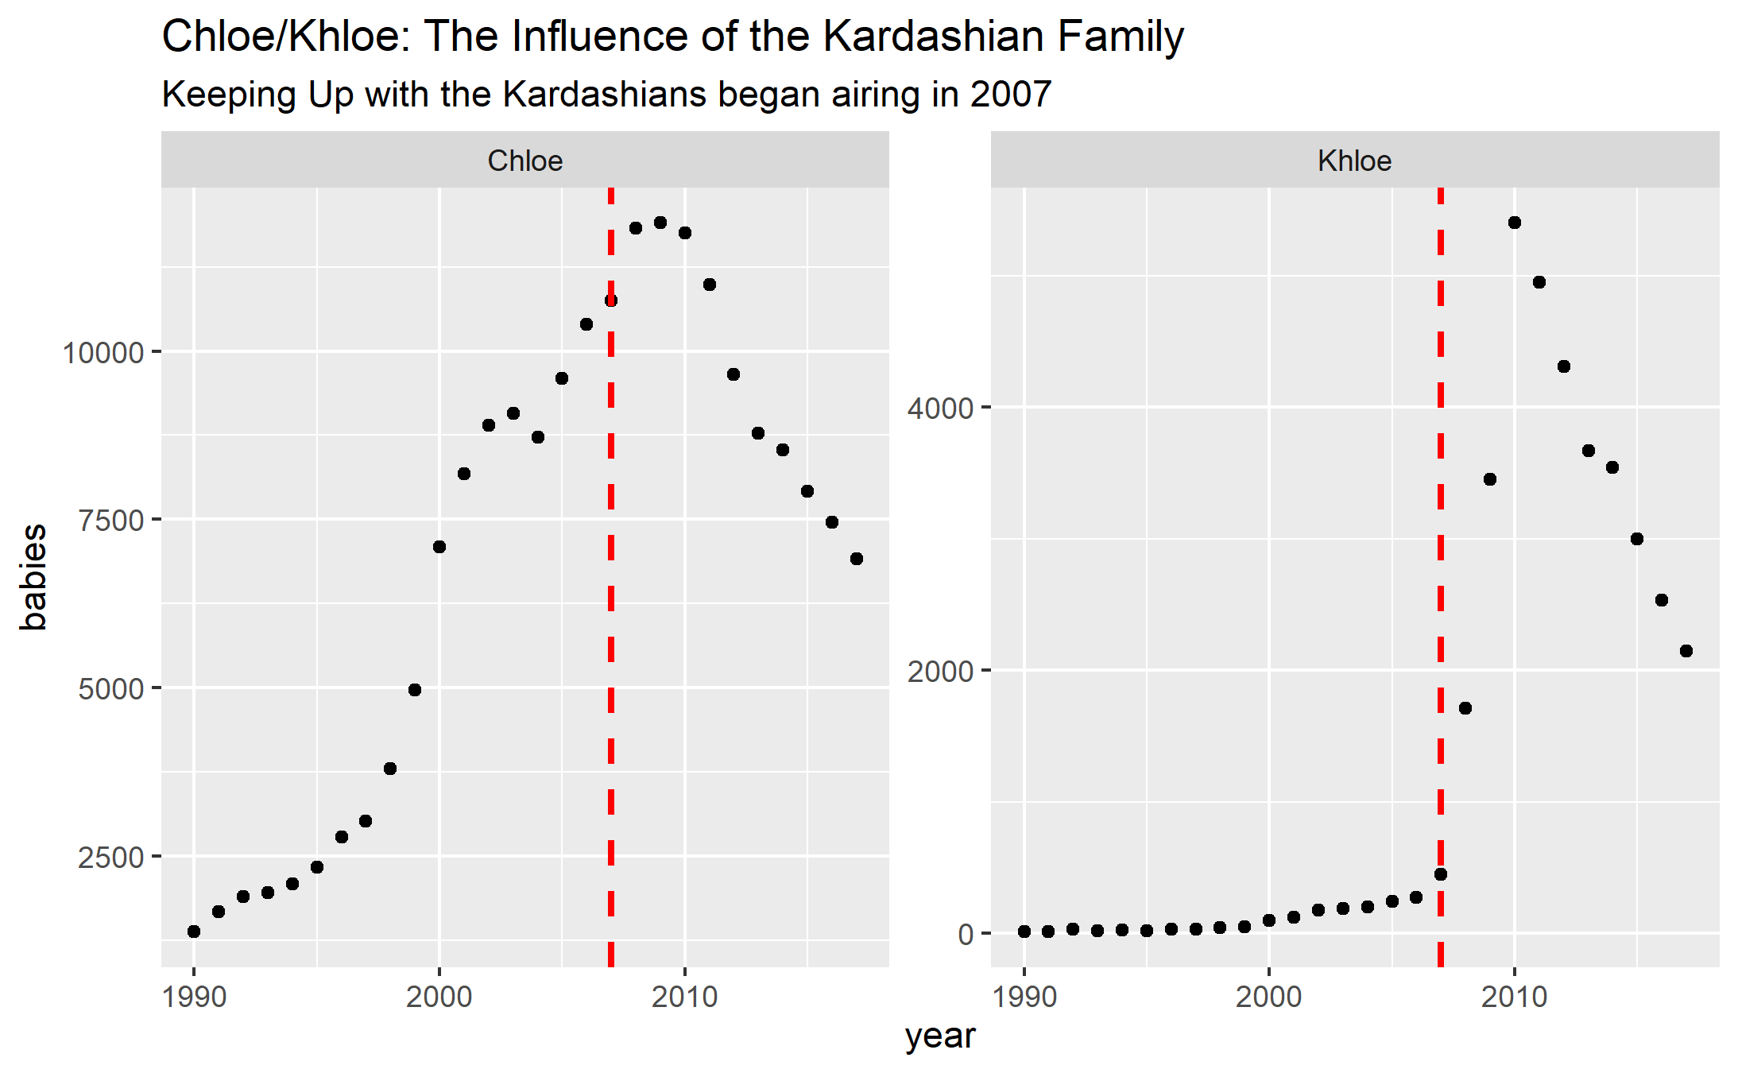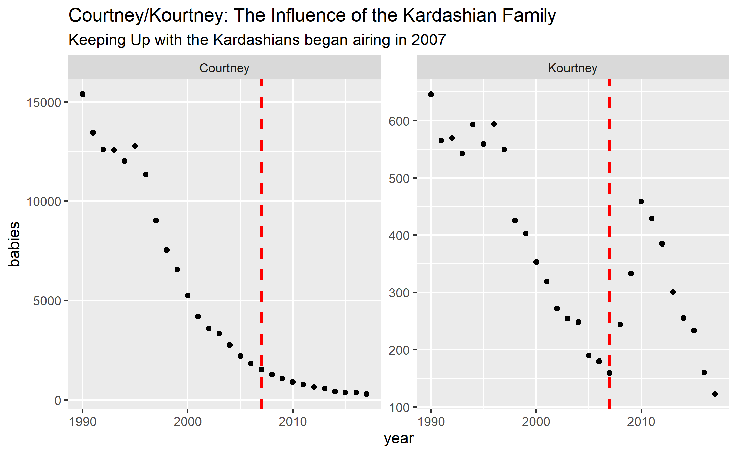

For the first-generation Kardashians, the only notable trends were around Khloe and Kourtney—both saw a jump, but neither one disrupted the trend for the traditional spelling of those names, though for Khloe and Chloe, the trends ended up aligning, with their popularity beginning to decline around the same time (as did Kourtney).

**Next Gen**

The next-generation Kardashians show much stronger trends. Here are some highlights:

* In the two years after Kourtney Kardashian named her son Mason, the name went from 34th most popular boys name (out of 14,343) to the 12th most popular to the 2nd most popular, an increase of just under 9,000.
* The increased popularity for the name Penelope, though less staggering than Mason, is still pretty strong.
* It turns out North is mostly a boy’s name.
* Use of Dream and Reign, which had both previously been given to boys and girls, shifted for both genders; Saint shifted only for boys.

## Once Upon a Time, There Were 3 Little Girls Who Went to the Police Academy

Overall, there are some pretty obvious trends here for the names of both the actresses, and the characters, but there are actually really interesting trends when you look at a lot of these up close:

**Farrah Fawcett aka Jill Munroe**

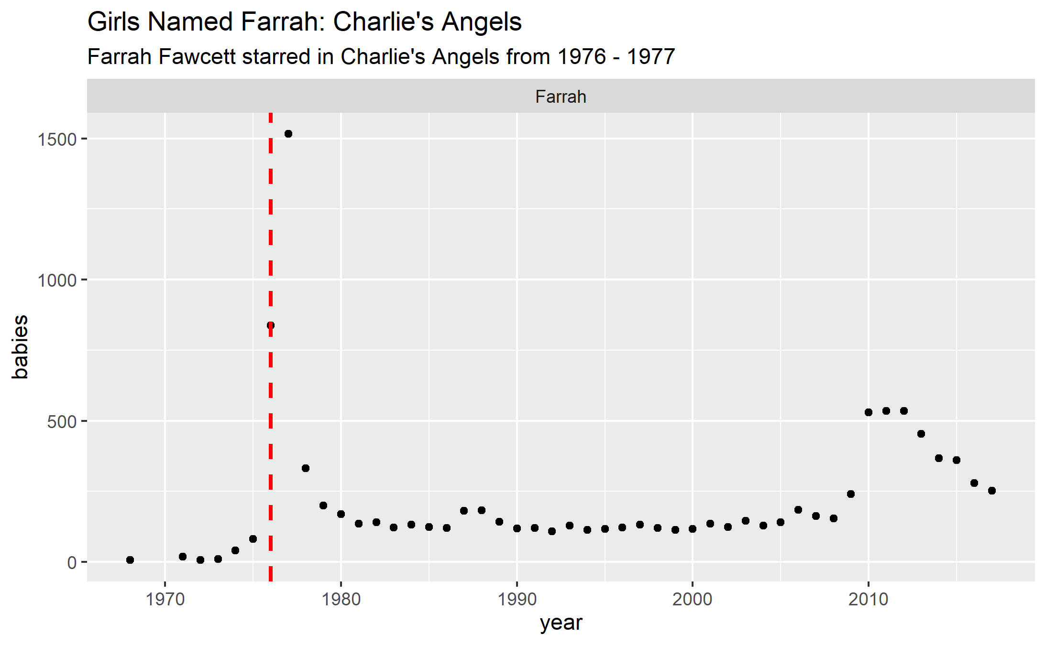

The relatively uncommon name “Farrah” has a small jump coinciding with the actress’s appearance on the show: pretty standard.**

The more interesting one is Jill which looks like the only name that doesn’t show a response to the show’s release.

Except…check this out:

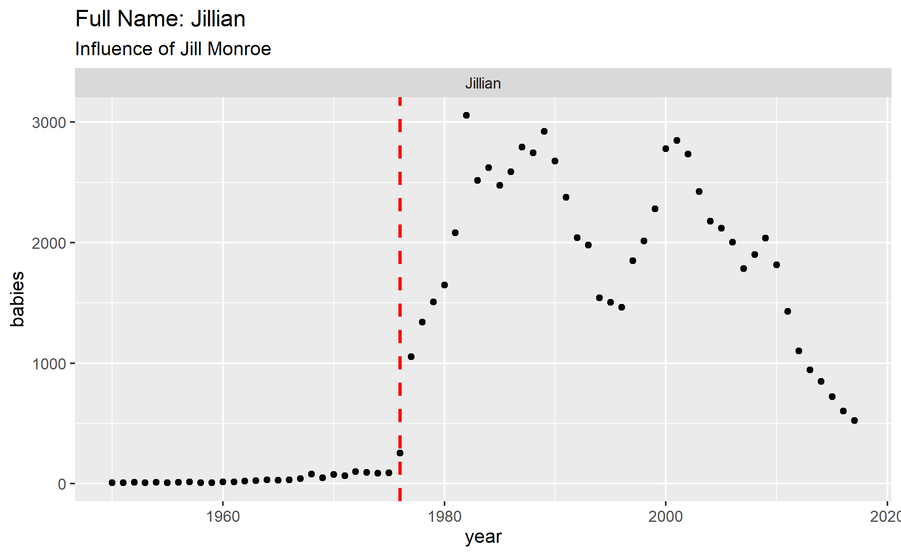

People didn’t start naming their children Jill outright, but the name “Jillian” did get a sizeable bump.

**Kate Jackson aka Sabrina Duncan**

The name Kate was already trending up but experienced a nice jump and an intensifying trend after the release of the show before beginning to decline in the mid-80s. If you’re wondering why the trend goes back up in the mid-90s: Kate Winslet. Yes, the name Leonardo took a nice big jump in 1997 too, as did Rose. **Chart, scatter chart
**

As for Sabrina, the name had a big jump in ’76, and actually had its next big trend shift at the same time as Kate: the mid-90s. My best guess is that’s because of *Sabrina the Teenage Witch*, but I didn’t find any related trends (i.e. Melissa, Harvey), so it’s definitely harder to say.

You’re probably also wondering, if Jill made the name Jillian get more popular, did Kate make the name Katherine/Catherine get more popular? The answer: maybe, at least for Kate Jackson.

With a more popular name, it’s *way* harder to say because there are so many potential influences (I spent like 4 hours trying to track Katharine Hepburn’s influence and got nowhere), but there’s a definite jump in the “Katherine” spelling from ’76 to ’77, and the declining trend for the “Catherine” spelling reverses at the same time.

**Jaclyn Smith AKA Kelly Garrett**

Again, the movement of the name Kelly is pretty standard: big jump but quick reversal.

What happens to Jaclyn I think is one of the coolest examples because it shows really solid cause and effect. Not only does Smith popularize the nontraditional spelling of “Jaclyn” she reverses the trend on the spelling “Jacqueline”, which peaked, unsurprisingly, during Jackie Kennedy’s tenancy in the White House.

Further evidence of the specific impact of *Charlie’s Angels*: Jackie Kennedy did not have any impact on the nontraditional spelling, but she did impact the popularity of naming a baby girl just Jackie, while Jaclyn smith did not.

## “You got people to name their children after you?” “What, like it’s hard?”

The name Reese was already trending up as a boys’ name in 1999 when the release of *Cruel Intentions,* starring Reese Witherspoon, started an upward trend in its popularity for girls, which was intensified after the release of *Legally Blonde*. As Reese’s popularity for girls surpassed boys, it started trending downward as a boys’ name.

In 2005, the name’s popularity for girls jumped again with the release of *Walk the Line.*

As for the characters she played, there wasn’t a really strong trend around Annette (*Cruel Intentions)*, but both Elle and June responded to their respective movie releases.

Other notable shifts: After the release of *Walk the Line,* the name Joaquin took a big jump even by the standards of its sharply inclining popularity since the release of Gladiator. As for characters, the names Sebastian (*Cruel Intentions*) and Johnny (*Walk the Line*) also responded to their respective movies.

## Here’s Looking at You Kid

Four names, four different types of trends: the film *Casablanca* did nothing for the name Humphrey but intensified the trending popularity of the name Ingrid, introduced the name Ilsa to the US, and seems to have sparked a trend of naming children Rick directly instead of using it as a nickname.

## In Every Generation, There is A Chosen One

* It’s completely irrelevant to this analysis, but my favorite data point: for a brief, shining moment in 1971, six sets of parents named their son Buffy. That said, not even one of, in my opinion, the most badass female characters ever could resurrect the name Buffy’s modest popularity of the mid-twentieth century. I do wonder if its small reemergence right around the show’s end, after a near decade of absence, could be credited to the show.
* The trend for naming boys Angel, already moving up, seems to intensify with the show, but unlike other names, the show’s start does not disrupt the trending popularity of Angel as a girl’s name.
* As hippy-dippy as the name Willow sounds, it wasn’t super popular in the ‘60s, and the start of the show seems to have kickstarted the continually growing popularity for the name.
* The show’s beginning coincides with a trend of naming children Xander outright as opposed to having it as a nickname, and it first appeared on the U.S. Popularity charts in 1999 (2 years after the show’s inception). The big jump, however, occurs the year the show ended. I haven’t found a reason that jump may have occurred (though if you can think of one, please enlighten me), so I’m going to give the credit to the loyal and adorkable Xander Harris.

## Meryl Vs Dustin

You can actually watch the trends of the name Dustin jump with many of his movies, but the biggest leap comes after *Kramer vs. Kramer.*

Whether it’s because that film netted him his first Academy Award or because he costarred with Queen Meryl, I’ll let you decide.